

Mohammad Ali Jinnah University

Chartered by Government of Sindh - Recognized by HEC

**Lab Task 1**

**Name:** Muhamad Fahad

**Id:** FA19-BSSE-0014

**Subject:** DBMS Lab

**Section:** BM

**Teacher:** Rimsha Javed

**Date:** Tuesday, March 23, 2021

**Question**

1. **Kindly Make the user login and password on the database as mention in the lab task file and take the screenshots in a word file and submit it.**
2. **(.sql file or .txt file) which hold your Queries Related to Task.**
3. **Database diagram of your task.  
   I want from You all are 3 files one is .sql file or .txt file and the second one is a word file and database diagram.**

**Answer:**

***User login and password:* 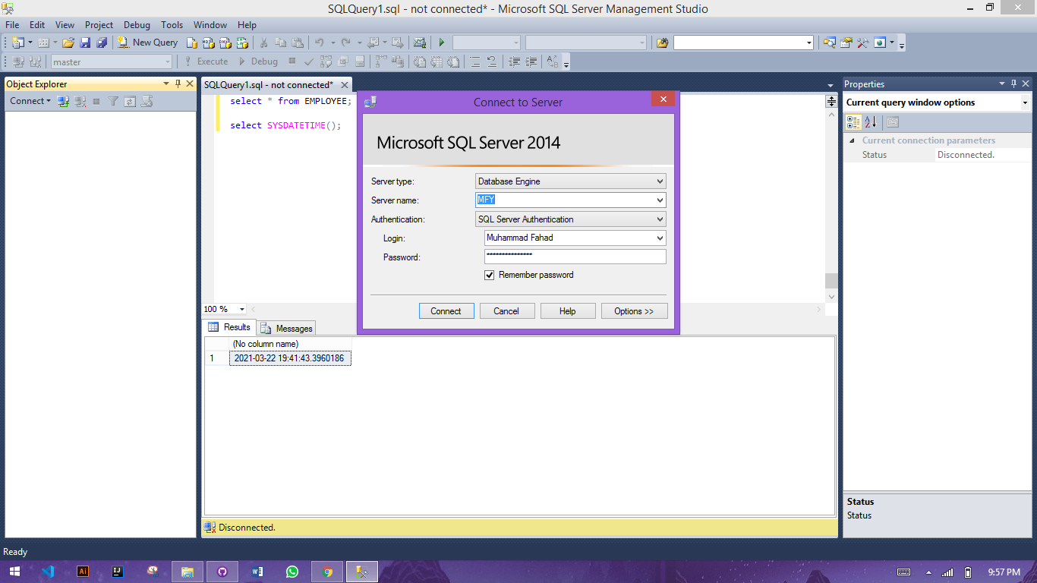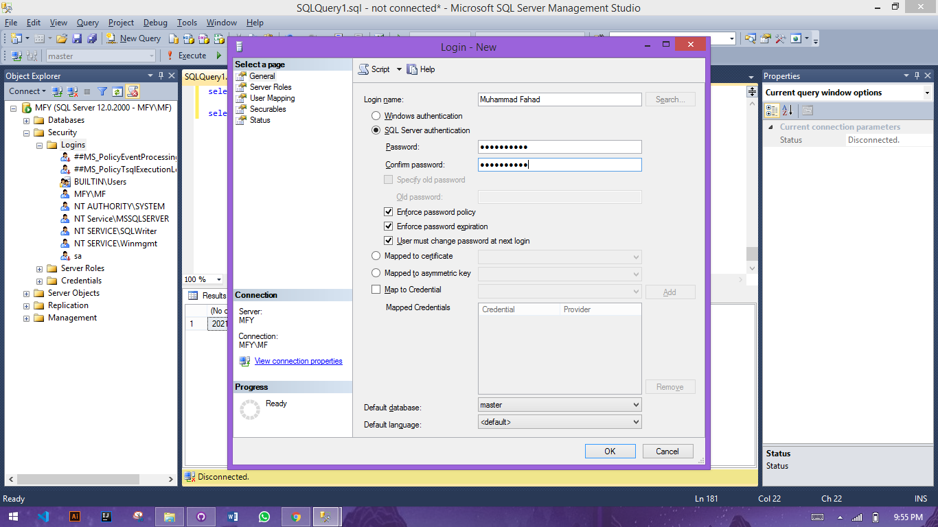**

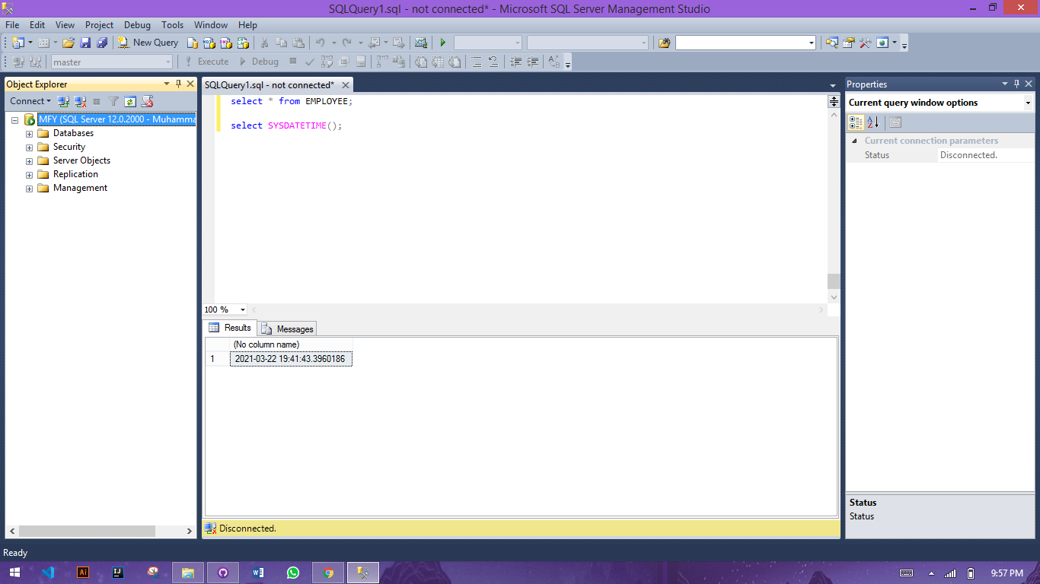**SQL Query:**

create database MAJU

use MAJU;

CREATE TABLE Students(

ST_id VARCHAR(15) NOT NULL,

ST_name VARCHAR(10),

ST_Regdate VARCHAR(12),

ST_CGPA DECIMAL(3, 2),

ST_Semes int,

deptno VARCHAR(10)

);

CREATE TABLE EMPLOYEE(

empno INTEGER NOT NULL,

name VARCHAR(10),

job VARCHAR(9),

boss INTEGER,

hiredate VARCHAR(12),

salary DECIMAL(7, 2),

comm DECIMAL(7, 2),

deptno INTEGER

);

CREATE TABLE marks(

ST_id VARCHAR(15) NOT NULL,

C_id VARCHAR(14) NOT NULL,

GPA VARCHAR(13)

);

CREATE TABLE salary(

empno INTEGER NOT NULL,

Salary INTEGER NOT NULL,

Methods VARCHAR(10) NOT NULL

);

CREATE TABLE course (

C_id VARCHAR(10) NOT NULL,

C_name VARCHAR(9) NOT NULL,

C_Creadit DECIMAL(7, 2),

Teacher DECIMAL(7, 2)

);

-- Primary Keys and constraints

ALTER TABLE Students

ADD CONSTRAINT ST_PK

PRIMARY KEY (ST_id);

ALTER TABLE EMPLOYEE

ADD CONSTRAINT em_pk

PRIMARY KEY (empno);

ALTER TABLE course

ADD CONSTRAINT c_PK

PRIMARY KEY (C_id);

ALTER TABLE salary

ADD CONSTRAINT empfk

FOREIGN KEY (empno)

REFERENCES EMPLOYEE (empno);

ALTER TABLE marks

ADD CONSTRAINT marksfk

FOREIGN KEY (ST_id)

REFERENCES Students (ST_id);

ALTER TABLE marks

ADD CONSTRAINT msfk

FOREIGN KEY (C_id)

REFERENCES course (C_id);

INSERT INTO course VALUES ('CS8983', 'DBMS',3,3);

INSERT INTO course VALUES ('CS456', 'DBMS lab',3,3);

INSERT INTO course VALUES ('CS8984', 'DDA',3,3);

INSERT INTO course VALUES ('CS8988', 'DSA',3,3);

INSERT INTO EMPLOYEE VALUES (7839, 'KING', 'PRESIDENT', NULL, '1981-11-17', 5000, NULL, 10);

INSERT INTO EMPLOYEE VALUES (7566, 'JONES', 'MANAGER', 7839, '1981-04-02', 2975, NULL, 20);

INSERT INTO EMPLOYEE VALUES(7788, 'SCOTT', 'ANALYST', 7566, '1982-12-09', 3000, NULL, 20);

INSERT INTO EMPLOYEE VALUES(7876, 'ADAMS', 'CLERK', 7788, '1983-01-12', 1100, NULL, 20);

INSERT INTO EMPLOYEE VALUES(7902, 'FORD', 'ANALYST', 7566, '1981-12-03', 3000, NULL, 20);

INSERT INTO EMPLOYEE VALUES(7369, 'SMITH', 'CLERK', 7902, '1980-12-17', 800, NULL, 20);

INSERT INTO EMPLOYEE VALUES (7698, 'BLAKE', 'MANAGER', 7839, '1981-05-01', 2850, NULL, 30);

INSERT INTO EMPLOYEE VALUES(7499, 'ALLEN', 'SALESMAN', 7698, '1981-02-20', 1600, 300, 30);

INSERT INTO Students VALUES('FA19BSSE0014', 'M.Fahad', '1981-02-22', 3.60, 4, 'BSSE');

INSERT INTO Students VALUES('FA19BSSE0030', 'M', '1981-02-22', 3.60, 4, 'BSSE');

INSERT INTO Students VALUES('FA19BSSE0020', 'Muhammad', '1981-02-22', 3.60, 4, 'BSSE');

INSERT INTO Students VALUES('FA19BSSE0024', 'Fahad', '1981-02-22', 3.60, 4, 'BSSE');

select * from EMPLOYEE;

select * from Students;

select * from marks;

select * from salary;

select * from course;

drop table Students

drop table EMPLOYEE;

drop table marks;

drop table salary;

drop table course;

**Diagram**